Assignment 6

Task Description 1

• Use AI to complete a student class with attributes and a method.
• Check output
• Analyze the code generated by AI tool

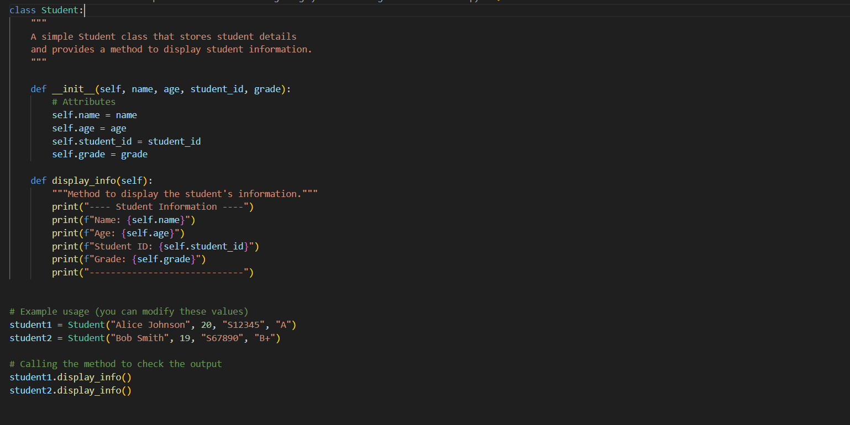

Practical Output:

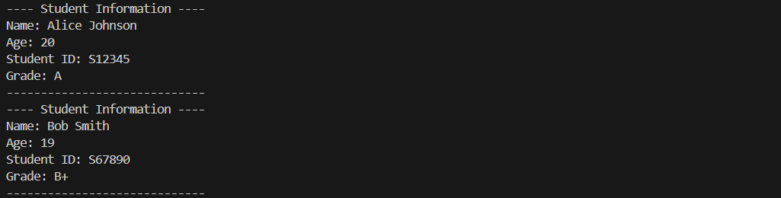

1 Class Definition
- Student encapsulates name, age, and grades as attributes.
- Methods handle behaviours like computing average and displaying info.
2 Constructor __unit__
- Initializes each student with name, age, and grades list.
- self. Grades store all the student’s grades.
3 Method average grade
- Checks if the grades list is empty.
- Calculates average using sum(grades)/len(grades).
- Returns None if no grades are present.
4 Method displays info
- Prints the student’s name, age, and grades.
- Calls average grade () and formats output to 2 decimal places.
5 Example Usage
- student1 has grades → prints average.
- student2 has no grades → prints “No grades available.”

Task Description 2

• Prompt AI to complete a function that prints the first 10 multiples of a number using a loop.
• Analyze the generated code
• Ask AI to generate code using other controlled looping

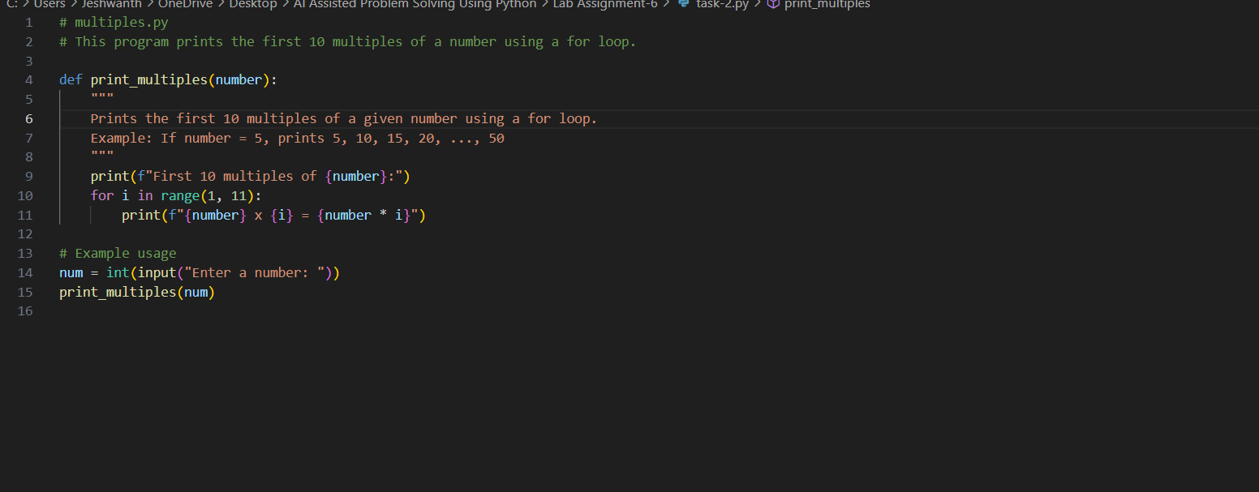

Practical Output:

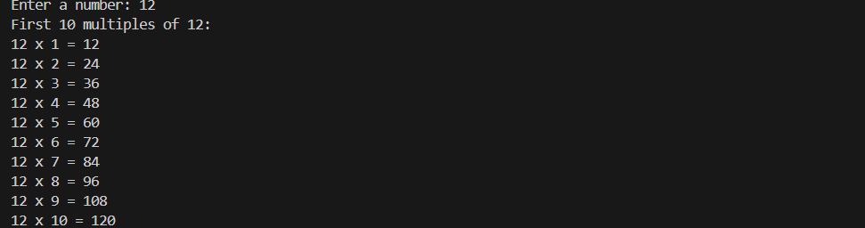

1 Function Definition
- print multiples(number) takes one argument number.
- It calculates and prints the first 10 multiples of that number.
2 For Loop
- for i in range (1, 11) iterates from 1 to 10.
- Each iteration multiplies number * i and prints it.
3 Example Usage
- Prompts the user to input a number.
- Calls print multiples (Num) to display the multiples.
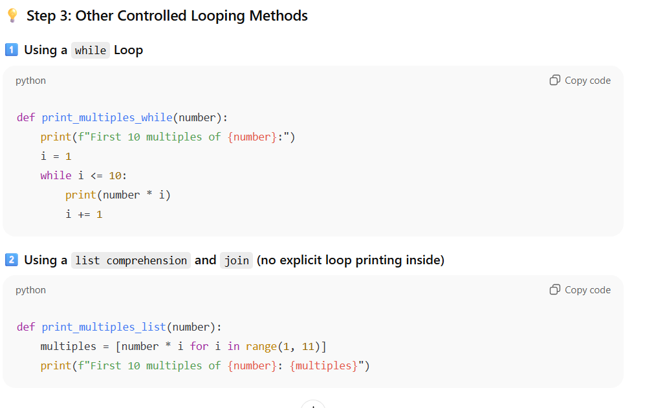

Task Description 3

• Ask AI to write nested if-Elif-else conditionals to classify age groups.
• Analyze the generated code
• Ask AI to generate code using other conditional statements

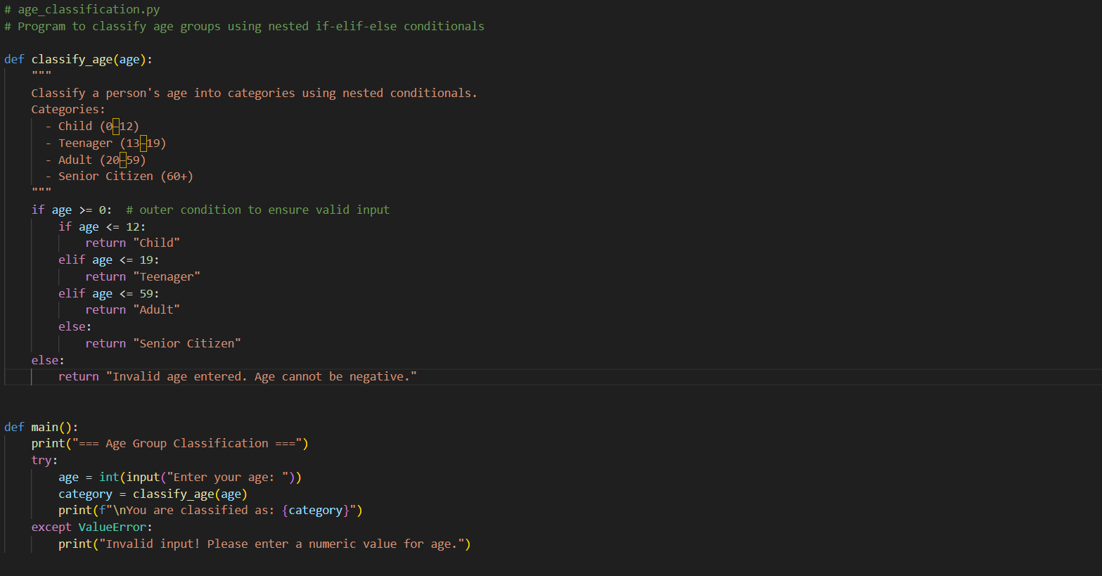

Practical Output:

Code Analysis
- Function classify age(age)
  - Takes an integer age as input.
  - Uses nested conditional blocks:
    - Outer if checks if the age is non-negative.
    - Inner if-elif-else determines the correct category.
  - Returns a string describing the age group.
- main() Function
  - Prompts the user for input.
  - Calls the classifier function and displays the result.
  - Includes a try-except block to handle non-numeric input.
- Execution Guard
  - if __name__ == "__main__": ensures this script runs only when executed directly.
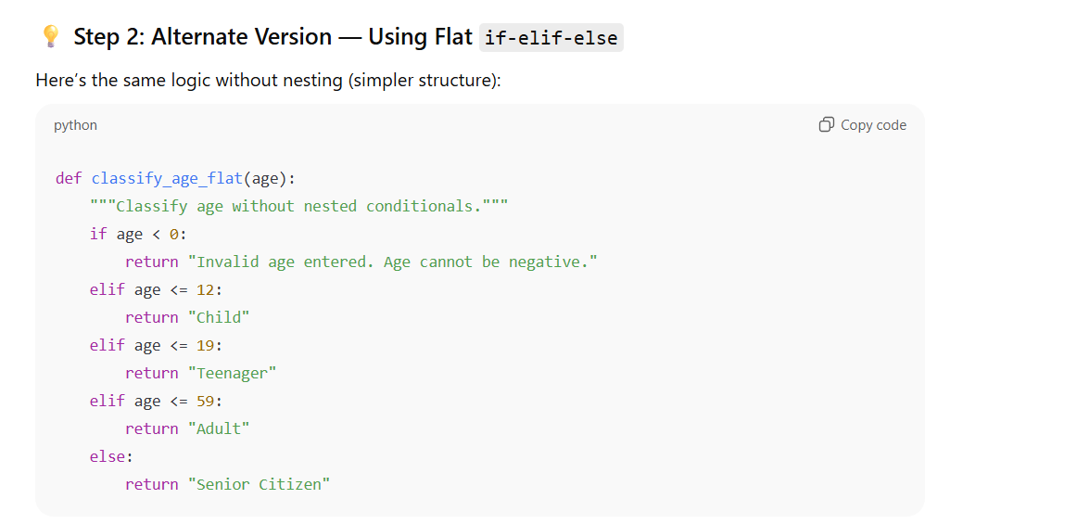
Explanation: -
Condition | Meaning | Output
age < 0 | Invalid input | “Invalid age entered.”
0 ≤ age ≤ 12 | Childhood stage | “Child”
13 ≤ age ≤ 19 | Teenage stage | “Teenager”
20 ≤ age ≤ 59 | Working-age adult | “Adult”
age ≥ 60 | Retirement stage | “Senior Citizen”

Task Description 4

• Generate a sum_to_n () function to calculate sum of first n numbers
• Analyze the generated code
• Get suggestions from AI with other controlled looping

Code

# Function to calculate the sum of first n natural numbers using a for loop

# sum_to_n.py
# Program to calculate the sum of first n natural numbers using loops

def sum_to_n(n):
"""
Calculate the sum of the first n natural numbers using a for loop.
Example: n=5 → 1+2+3+4+5 = 15
"""
total = 0
for i in range(1, n + 1):
total += i
return total

def main():
print("=== Sum of First N Natural Numbers ===")
try:
n = int(input("Enter a positive integer (n): "))
if n <= 0:
print("Please enter a number greater than zero.")
return

result = sum_to_n(n)
print(f"\nSum of first {n} natural numbers is: {result}")

except ValueError:
print("Invalid input! Please enter an integer value.")

if __name__ == "__main__":
main()

Explanation:
1. Comments and Docstrings
# sum_to_n.py
# Program to calculate the sum of first n natural numbers using loops
- # starts a comment in Python.
- Comments are ignored by the interpreter.
- These describe what the program does — good coding practice!
🟢 2. Function Definition
def sum_to_n(n):
- Defines a function named sum_to_n that takes one parameter n.
- This function will compute the total sum of numbers from 1 to n.
🟢 3. Docstring
"""
Calculate the sum of the first n natural numbers using a for loop.
Example: n=5 → 1+2+3+4+5 = 15
"""
- This is a docstring — a string right under the def line.
- It documents what the function does.
- Developers can view it later using help(sum_to_n).
🟢 4. Initialize the Total
total = 0
- Creates a variable total and sets it to zero.
- This variable will accumulate the running sum as we loop.
🟢 5. For Loop
for i in range(1, n + 1):
total += i
- range(1, n + 1) generates numbers from 1 up to n.
  - Example: if n = 5, the range gives [1, 2, 3, 4, 5].
- The loop runs once for each number in that range.
- Each time, it adds the current number i to total.
Example when n = 5:
Iteration | i | total after addition
1st | 1 | 1
2nd | 2 | 3
3rd | 3 | 6
4th | 4 | 10
5th | 5 | 15
So the final total = 15.
🟢 6. Return the Result
return total
- Sends the calculated sum back to wherever the function was called from.
- The function’s output can be stored in a variable or printed.
🟢 7. Main Function
def main():
- The main() function acts as the program’s starting point.
- It handles user input, validation, and output display.
🟢 8. Print Title
print("=== Sum of First N Natural Numbers ===")
- Displays a heading to make output user-friendly.
🟢 9. Input Handling
n = int(input("Enter a positive integer (n): "))
- The input() function reads text from the user.
- int() converts it to an integer.
- If the user enters non-numeric text (like “abc”), Python will raise a ValueError — handled by try-except.
🟢 10. Validation
if n <= 0:
print("Please enter a number greater than zero.")
return
- Checks that the user entered a positive number.
- If not, the function exits early using return.
🟢 11. Function Call
result = sum_to_n(n)
- Calls the sum_to_n() function defined earlier.
- Stores its return value (the sum) in result.
🟢 12. Display Result
print(f"\nSum of first {n} natural numbers is: {result}")
- Uses an f-string for formatted output.
- Prints the value neatly.
Example output:
Sum of first 10 natural numbers is: 55
🟢 13. Exception Handling
except ValueError:
print("Invalid input! Please enter an integer value.")
- If a user types something that isn’t a number, this block runs.
- Prevents the program from crashing and gives a clear error message.
🟢 14. Entry Point Check
if __name__ == "__main__":
main()
- This ensures the program runs only when executed directly, not when imported as a module.
- It’s a Python standard convention.
- So when you run python sum_to_n.py, it calls main() automatically.
🧾 Example Run in VS Code
=== Sum of First N Natural Numbers ===
Enter a positive integer (n): 10

Sum of first 10 natural numbers is: 55
⚡ Alternative Controlled Loop — while Loop
To understand looping better, here’s a while-loop version:
def sum_to_n_while(n):
total = 0
i = 1
while i <= n:
total += i
i += 1
return total
Here:
- The loop continues while i <= n.
- You must manually increment i each time.
- It produces the same result.

Practical output:-

Task Description 5

• Use AI to build a Bank Account class with deposit, withdraw, and balance methods.
• Analyze the generated code
• Add comments and explain code

Code:
class BankAccount:
"""
Represents a bank account with functionalities to deposit, withdraw, and check the balance.
"""

def __init__(self, initial_balance=0.0):
"""
# bank_account.py
# Program to demonstrate a BankAccount class with deposit, withdraw, and balance methods

class BankAccount:
"""
A simple class to represent a bank account.
It supports depositing money, withdrawing money, and checking the balance.
"""

def __init__(self, account_holder, initial_balance=0.0):
"""
Constructor method to initialize account details.
:param account_holder: str - Name of the account holder
:param initial_balance: float - Initial amount in the account
"""
self.account_holder = account_holder
self.balance = initial_balance
print(f"Account created for {self.account_holder} with balance ₹{self.balance:.2f}")

def deposit(self, amount):
"""
Method to deposit money into the account.
:param amount: float - Amount to deposit
"""
if amount > 0:
self.balance += amount
print(f"Deposited ₹{amount:.2f}. New balance: ₹{self.balance:.2f}")
else:
print("Deposit amount must be positive!")

def withdraw(self, amount):
"""
Method to withdraw money from the account.
:param amount: float - Amount to withdraw
"""
if amount <= 0:
print("Withdrawal amount must be positive!")
elif amount > self.balance:
print("Insufficient balance!")
else:
self.balance -= amount
print(f"Withdrew ₹{amount:.2f}. Remaining balance: ₹{self.balance:.2f}")

def get_balance(self):
"""
Method to return the current account balance.
:return: float - Current balance
"""
print(f"Current balance for {self.account_holder}: ₹{self.balance:.2f}")
return self.balance

# ----------------------------
# Example Usage (Main Program)
# ----------------------------
def main():
print("=== Welcome to Simple Bank Account Program ===\n")

# Create an account with an initial balance
account = BankAccount("Alice", 1000.0)

# Perform deposit and withdrawal operations
account.deposit(500.0)
account.withdraw(200.0)
account.get_balance()

# Trying invalid transactions
account.deposit(-100.0)
account.withdraw(2000.0)

if __name__ == "__main__":
main()

Explanation:

Class Definition
class Bank Account:
- Defines a blueprint for creating bank account objects.
- Each object represents a single customer’s bank account.
2️⃣ Constructor (__init__)
def __init__(self, account_holder, initial_balance=0.0):
- Automatically called when a new object is created.
- Initializes:
  - self.account_holder: Stores the customer’s name.
  - self.balance: Keeps track of current balance.
- The optional argument initial_balance defaults to 0.0.
Example:
account = BankAccount("Alice", 1000)
creates an account for Alice with ₹1000 starting balance.
3️⃣ Deposit Method
def deposit(self, amount):
- Adds money to the account.
- Checks if the amount is positive before updating the balance.
Example:
account.deposit(500)
→ Increases balance by ₹500.
4️⃣ Withdraw Method
def withdraw(self, amount):
- Subtracts money from the account.
- Validates:
  - The amount must be positive.
  - The account must have enough funds.
- Prevents overdrawing.
Example:
account.withdraw(200)
→ Decreases balance by ₹200 if sufficient funds exist.
5️⃣ Get Balance Method
def get_balance(self):
- Returns the current balance.
- Also prints a message showing the balance.
Example:
account.get_balance()
→ Displays Current balance for Alice: ₹1300.00
6️⃣ Main Program
def main():
- Demonstrates the class functionality:
  - Creates a BankAccount object.
  - Performs deposits and withdrawals.
  - Displays balance.
  - Tests invalid transactions.
🧾 Sample Output
=== Welcome to Simple Bank Account Program ===

Account created for Alice with balance ₹1000.00
Deposited ₹500.00. New balance: ₹1500.00
Withdrew ₹200.00. Remaining balance: ₹1300.00
Current balance for Alice: ₹1300.00
Deposit amount must be positive!
Insufficient balance!

